**Modelling California Bighorn Sheep Habitat**

**Along the Northern Slopes of Kamloops Lake**

**______________________________________________**

**ENVS 4480/5480**

Amar Brown, Carter Davey, Eric Marasco, and Larisa Murdoch



**Table of Contents**

Introduction 2

Methods 2

Sheep Location Data: 2

Data Tile Generation and Ground Point Classification: 3

Digital Elevation Model and Terrain-Based Layers using the DEM: 4

Results: 4

Discussion: 5

Works Cited: 5

Appendix: 5

# **Introduction**

Bighorn sheep (*Ovis canadensis*) populations across western North America once contained millions of individuals (*Smith et al 2015*). However, as a result of diseases from domestic sheep, habitat loss, and resource competition with livestock and other ungulates, bighorn numbers began to decline around the 20th century (*Parr et al 2018, Lula et al 2020*).

They are known to have specialized habitat requirements and strong site fidelity to areas associated with rugged, steep ‘escape’ terrain as it impedes predator movement (*DeCesare and Pletscher 2006, Jones et al. 2022, Blum 2023*). Escape terrain can be defined as an area with well-defined zones (or patches) formed by broken terrain with a slope steepness of 60-100%. Additionally, areas with high elevation and high horizontal visibility are also important predictors for bighorn habitat selection (*Smith et al. 1991, Zeigenfuss et al. 2000, Donovan et al. 2021*). Higher visibility suggests that an animal will have a better chance of detecting a predator approaching and thus will have a chance to escape (*Iribarren and Kotler 2011*). Horizontal visibility is a measure indicative of density of surrounding vegetation; high visibility allows sheep to detect predators and maintain contact with other herd members. Research indicates that bighorn avoid areas that had less than 55% horizontal visibility. (*Smith et al. 1991, Zeigenfuss et al. 2000*). Another important factor of habitat selection is distance to water. Studies have demonstrated that 85% of bighorn activity occurred within 3.2 km of usable water sources. Seeps, springs, perennial snow patches, streams, rivers, ponds, lakes, and reservoirs all qualify as bighorn watering sources (*Smith et al. 1991*). The percentage of vegetation cover can be a predictor for habitat selection as forage availability is important for ewes to meet nutritional requirements (*Donovan et al 2021, Jones et al 2022*).

The habitat selected by ewes is essential for the survival of their lambs as it influences predator detection and food availability (*Uboni et al. 2017*). When lambs are vulnerable to predation, ewes tend to restrict themselves to areas with more protection, even if other resources like forage are limited there. As a result, females frequently prefer escape terrain over other resources (*Alvarez-Cardenas et al. 2001, Hoglander et al. 2014*). Birthing of the lambs typically occurs between the months of April and July, during which females will seek out discrete and rugged areas and sites with steep slopes as this likely reduces predation on the lambs from terrestrial predators (*Bangs et al. 2005*). Following the lambing season, bighorn sheep ewes continue to select features associated with predator avoidance and maximise reproductive fitness, including rugged and steep slopes, areas closer to grassland and less vegetative obstruction (*DeCesare and Pletscher, 2006, Jones et al. 2022*).

Bighorns are known to be diurnal feeders and alternate grazing and resting throughout the day, while only bedding down for the night at dusk. During lambing season, females spend a higher proportion of time bedded down than males (*Wang et al. 2018*). As a result of that, the bed sites selected at night are expected to fall within the preferred habitat that bighorn select for. All habitat-selection analyses follow the broad assumption that selection is connected to better habitat quality and population fitness (*DeCesare and Pletscher, 2006*). To predict habitat selection, animal abundance, or measure reproductive success, habitat suitability models can be used (*Zeigenfuss et al. 2000*).

Along the Thompson River in British Columbia, the California bighorn sheep population has declined by approximately 50% over the last decade. In this area, there are three subpopulations that make up the Kamloops population of bighorn: the Kamloops Lake North herd, the South Thompson herd, and the Battle/Spatsum herd. Of the three herds, Kamloops Lake North has declined more significantly than the others with an estimated 65% decline from 2013. This report will examine the Kamloops Lake North subpopulation of bighorn bedding sites by creating a habitat suitability model, predicting where expected resting sites would be with GPS location data.

# **Methods**

## **Sheep Location Data:**

Presence data of bighorn sheep resting areas was collected from GPS collar data. The collars are VERTEX PLUS Iridium. They log a GPS location every 4 hours and can be relocated in real time with VHF radio telemetry. Sheep collar data came from a subpopulation of the Thompson Region bighorn population located along the north of Kamloops Lake. There are 18 individuals collared within the North Kamloops Lake subpopulation, all of which are females ranging from five to twelve years old.

An area was deemed a bedding site when it met the following criteria was between April 1st and July 1st, 2023 (during the critical lamb rearing period), between the hours of 5:00 PM and 9:00 AM, point clusters were identified as a minimum of 2 points in a 10m radius of each other; only these clustered points were considered as suitable habitat. Areas beyond these clusters were randomly sampled to generate “absence” points.

### **Study Area:**

The study site is situated in the Thompson region within Interior British Columbia, Canada, located on the north of Kamloops Lake, to the west of Kamloops (50°46.257’ N, -120°51.683’ W). The landscape consists of rugged valley walls and terrain interposed with silt cliffs, rock faces, and talus slopes. The habitat here can be characterised by large areas of southerly and westerly-facing grassland slopes which are dominated by sagebrush (*Artemisia tridentata*) and bunchgrass (*Agropyron spicatum, Festuca scabrella, Festuca idahoensis, Elymus cinereus*). Disturbed areas are typically affected by invasive species such as cheatgrass (*Bromus tectorum*) and noxious weeds like any knapweed species (*Centaurea spp.*).

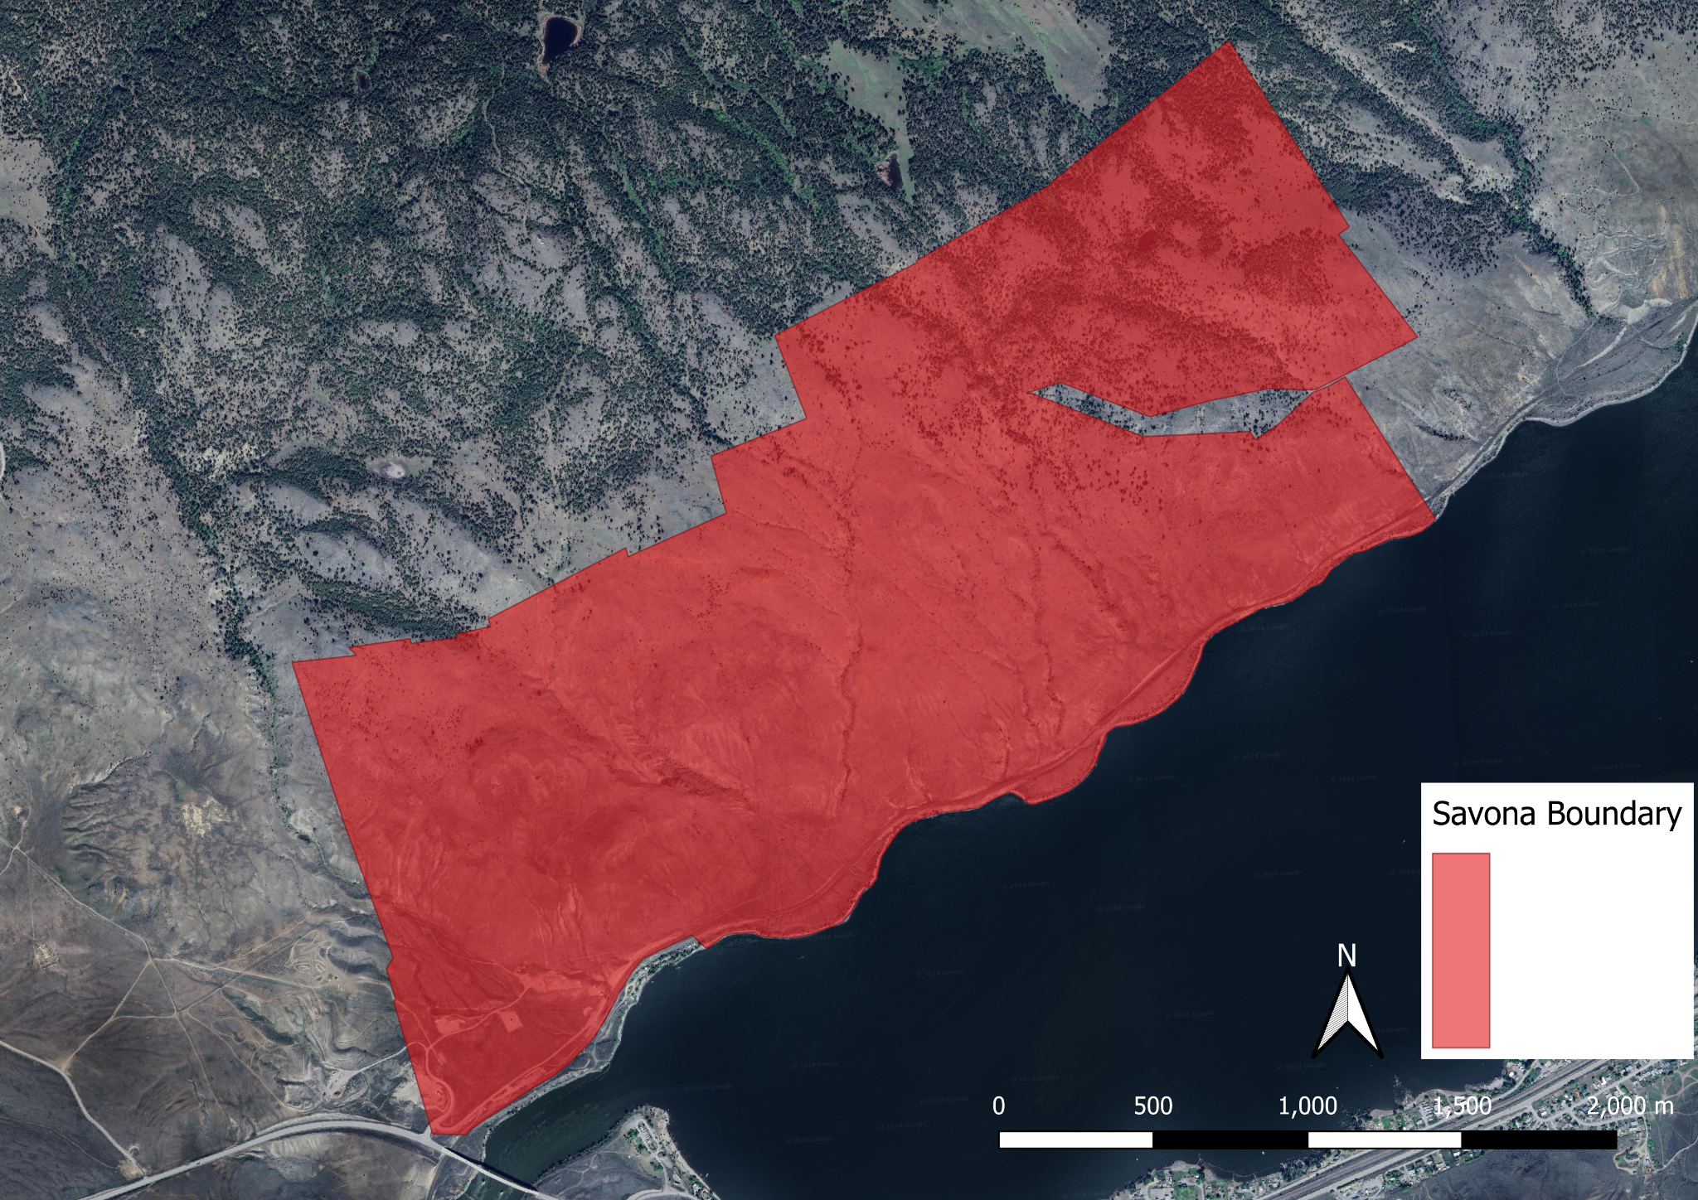

***Figure 1.*** *The boundary of the study site is positioned to the far northwestern end of Kamloops Lake. This study site was selected based on the high population of Bighorn Sheep in this area, and the corresponding areas of ideal sheep habitat. Ideal Bighorn sheep habitat is characterised by steep, rocky cliffs.*

## **Data Tile Generation and Ground Point Classification:**

The study data set we gathered was focused on a geographical region close to Savona, BC, north of Kamloops Lake (*Figure 1.*). The polygon and point data were provided as Geopackages and loaded into QGIS for observation. A point cloud developed from photogrammetric interpolation was provided in the form of a LAS file and loaded into RStudio using the lidR package (*Rousse et al. 2024*), (*Roussel et al. 2020*). To ensure the data was assessed in an efficient manner, it was tiled into smaller pieces (250m x 250m) using the catelog_retile function from the same lidR package (*Rousse et al. 2024*), (*Roussel et al. 2020*). Ground point classification was then performed using the tiled data using the Cloth Simulation Function (CSF) algorithm, using the sloop_smooth = TRUE option again using the lidR package (*Rousse et al. 2024*), (*Roussel et al. 2020*). The sloop smooth option was chosen because it considers the slope of the terrain that is being classified and reduces noise, improving the accuracy and identification of the ground points in the data.

## **Digital Elevation Model and Terrain-Based Layers using the DEM:**

For further analysis and visualization of the data that has been classified, a digital elevation model (DEM) raster image was created at a resolution of 2.5m per pixel using the rasterize_terrain function from the terra package. The next step in our data analysis was to create our terrain-based layers, this was conducted using various functions within the Rsagacmd package (*Pawley 2023*). Before we created our layers, we did some pre-processing to access some morphometric variables that would be used to calculate the certain model layers. Once the pre-processing was finished, we then created eight model layers to help visualize the correlation between these layers and the Big Horn point data.

The eight layers created were Aspect, Slope, Multiresolution Index of Valley Bottom Flatness (MRVBF), Multiresolution Index of Ridge Top Flatness (MRRTF), Terrain ruggedness index (TRI), Topographic position index (TPI), Topographic wetness index (TWI), and Topographic openness (TO). All eight layers were created into their own separate DEM and tif files, then all eight layers were joined into one object titled “model layers”. These layers were derived through specific SAGA GIS functions executed within RStudio, focusing on capturing the terrain's physical characteristics to inform our probability model using the Rsagacmd package (*Pawley 2023*). The terrain analysis involved calculating slope and aspect to understand terrain gradient and orientation. TRI measures the overall roughness or ruggedness of a terrain surface, while the TPI assesses the relative elevation of a location within its surrounding landscape. Furthermore, MRVBF quantifies characteristics of valley bottoms across multiple spatial scales, a higher MRVBF indicates a relatively higher proportion of flatter valley bottoms (*Gallant and Dowling 2003*). The MRRTF layer is a terrain analysis metric that quantifies the flatness of ridge tops across multiple scales (*Bioregional Assessment Program 2016*). TCA and SCA for hydrological flow, which were used as intermediate layers to calculate TWI. Our TWI layer represents moisture accumulation across the landscape, and TO expresses the dominance (positive) or enclosure (negative) of a location within a landscape (*Yokoyama et al. 2002*).

We then connected specific locations of interest with their environmental characteristics by extracting relevant data from raster layers. Using R's sf (*Bivand and Pebesma 2023, Pebesma 2018*) and terra (*Hijmans et al. 2023 Dec 15*) packages, we first loaded and checked the project's boundary and sheep location data. Next, we used the extract function from the terra package to pull values from the DEM derived topographic layers at each sheep location. We also cleaned up our data by removing any temporary files created during this process. This method allowed us to efficiently combine geographic locations with topographic data, setting the stage for deeper analysis into how these topographic factors relate to our points of interest.

## **Model Tuning and Validation:**

Initially, the necessary packages are loaded, including ranger for random forest classification, mlr3verse for machine learning functionalities, mlr3spatial for spatial data handling, using the sf (*Bivand and Pebesma 2023, Pebesma 2018*) and terra (*Hijmans et al. 2023 Dec 15*) packages for geospatial operations. Subsequently, the raster data for modelling is imported from the specified folder and manipulated to prepare for the tuning process. To initiate the model tuning process, parallelization is used for efficiency, utilizing all available CPU cores. The tuning parameters, such as the num.trees and mtry (number of variables randomly sampled at each split), are specified for the random forest model. A grid of hyperparameters is established, and a tuner object is created called tnr_design, for the design points. Spatial cross-validation is implemented using mlr3spatiotempcv, with inner and outer resampling defined for model evaluation. Evaluation metrics, such as our measure which was classif.prauc were selected

The tuning process iteratively searches for the optimal combination of hyperparameters using the defined tuner, evaluating performance via spatial cross-validation. Once tuning is complete, the best performing model is selected based on the obtained results. Furthermore, variable importance is analyzed to understand the contribution of different predictors to the model's performance. The importance of each variable was visualized using a bar plot, this provides us with information on how much weight is put on to each variable when the probability model is run. Furthermore, a confusion matrix is generated to assess the model's predictive performance across different classes.

## **Application and Visualization of Model:**

Finally, the trained model is applied to predict probabilities for each class across the raster layers. The resulting probability map is stored as Geo TIFF file for visualisation and further analysis. Additionally, the entropy of the predicted probabilities is calculated and visualised to provide insights into the uncertainty associated with the predictions.

# **Results**

The model's random forests were tested with 100, 250, 500, 750, 1000, 1500, and 2000 trees, alongside 11 distinct values for the 'mtry' parameter. The effectiveness of the model was validated through cross-validation, employing a 10-fold inner cross-validation for tuning the parameters and a 4-fold outer spatial cross-validation to evaluate the model's performance across different spatial segments of the dataset. Using these specific metrics for our model gave us the best model for our dataset.

In our analysis, we specifically assessed model performance using the Precision-Recall Area Under the Curve (PRAUC) score, with a particular focus on identifying the lowest score across various resampling iterations. The minimum PRAUC score achieved was 0.3489086.

Our confusion matrix revealed the model's ability to differentiate between classes. Specifically, the model correctly predicted 321 true positives and 443 true negatives, alongside 142 false positives and 131 false negatives. These outcomes yield a precision of 69.3%, a recall of 71.0%, and an F1 score of 70.2%. The precision indicates that 69.3% of the model's positive predictions were correct, while the recall shows that it correctly identified 71.0% of all actual positives.

|  |  |  |  |
| --- | --- | --- | --- |
|  | ***Truth*** | **TRUE** | **FALSE** |
| ***Response*** |  |  |  |
| **TRUE** |  | 321 | 142 |
| **FALSE** |  | 131 | 443 |

***Table 1.*** *Confusion Matrix produced from our tuned Ranger Classification Probability Model. By utilising these metrics produced by the confusion matrix, calculations were performed to calculate the accuracy of our model in predicting the percentage of positive predictions that were correctly classified by the model. This model had a recall (truth-positive rate) of 71%. This means that 71% of each true prediction was correctly classified by the model.*

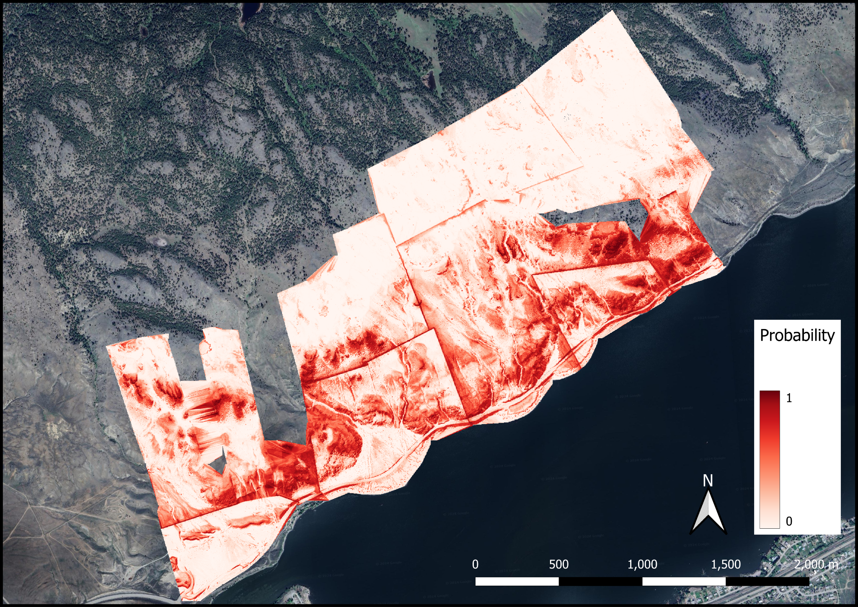

**Figure 2.**  *Probability map of sheep bedding locations within our study area, produced from our Classification Probability Model.*

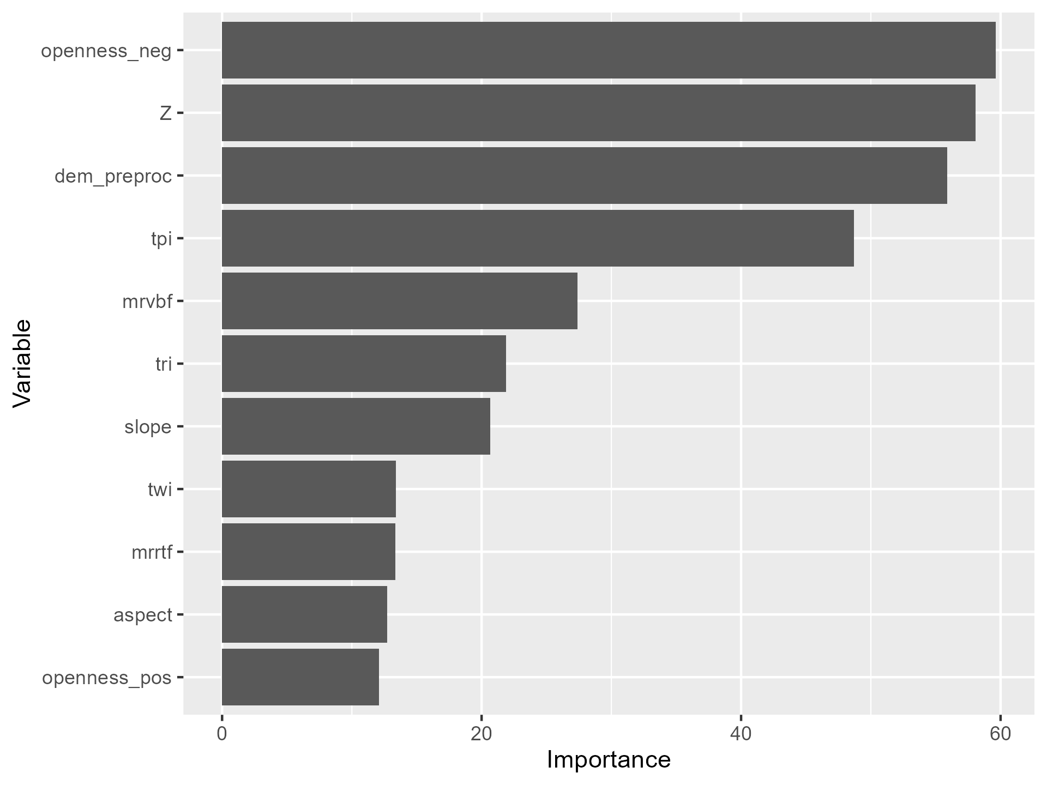

**Figure 3.**  *Importance plot of our 11 features within our model that predicted the probability of sheep bedding locations. Features with a higher importance influenced the probability map seen in Figure 2.*

# **Discussion:**

In our study, we assessed the effectiveness of our model using the Precision-Recall Area Under the Curve (PRAUC), a metric that evaluates how well the model distinguishes between classes across various decision thresholds. The lowest PRAUC score we observed was 0.3489086, indicating potential areas where our model's ability to consistently identify true positives could be improved.

Additionally, our analysis included a confusion matrix, which categorizes the predictions into true positives, true negatives, false positives, and false negatives. Specifically, our model correctly predicted 321 true positives and 443 true negatives, showcasing its capability to accurately identify both classes. However, the presence of 142 false positives and 131 false negatives points to misclassifications that need to be addressed. From these figures, we calculated a precision of 69.3% and a recall of 71.0%. Precision here means that approximately 69% of the model’s positive predictions were correct, while recall indicates that the model successfully identified about 71% of all actual positive cases. The F1 score, which combines precision and recall into a single measure, was 70.2%, suggesting a balanced performance between the model's accuracy and its completeness in detecting positive instances. These insights highlight both the strengths and limitations of our model, guiding future improvements to enhance its predictive accuracy and reliability.

The selection of suitable bedding sites by bighorn ewes is a critical aspect of their habitat utilization. In this report, we present an analysis of bighorn ewe bed site selection based on a habitat suitability model.

The importance plot (*Figure 3.*) shows the 11 features within our habitat suitability model that predict the probability of a bighorn bedding location. Of those 11, there were four features that had an importance value greater than 40 including the TPI, the dem preprocessing model, and negative topographic openness.

Notably, negative TO emerged as the most influential predictor of bighorn bed sites, likely due to the shelter and protection it offers against harsh weather conditions (*Poole et al., 2016*). It also suggests that when bedding, ewes prefer areas that provide hiding cover, potentially as predator avoidance strategy during the lambing season.

Additionally, elevation and TPI were also considered important features with values over 40. Numerous studies have identified that throughout the lambing season, ewes are selecting for habitats at higher elevations (*Zeigenfuss et al. 2000, DeCesare and Pletscher, 2006, Donovan et al. 2021*). As a result of that, ewes are likely bedding in areas with a higher elevation. TPI aids in delineating valleys and ridgetops, which are frequented by bighorn throughout the year (*Rubin et al., 2001*), further highlighting its importance in bed site selection.

The remaining features within the importance plot had values less than 40, and were likely not as important in determining the habitat bighorn ewes may select for bedding. These include MRVBF, TRI, slope, TWI, MRRTF, aspect and positive TO. While some of these features like slope and TRI are normally important predictors for habitat selected by bighorns, they may not be as valuable for ewes while they are choosing where to bed. The importance of the TWI was expected to be higher, however, ewes may not prioritize proximity to water sources while bedded down.

Although some features exhibited lesser importance values, they still contribute to our overall understanding of bighorn habitat preferences. The resulting probability map (*Figure 2.*) delineates areas with higher likelihoods of ewe resting or bedding. The redder an area is, the higher the probability of ewes choosing those locations as a bed site, indicating favourable attributes.

Understanding the patterns and intensity of habitat selection by species in heterogeneous environments is crucial for wildlife management efforts. This probability map is valuable for conservationists and land managers as it offers a visual representation of sheep habitat preferences, which is crucial for effective resource allocation and implementing effective management strategies. By pinpointing areas with higher bedding probabilities, we can better understand the environmental features sheep select for rest, which may include factors such as vegetation cover, terrain, and proximity to water sources. This understanding can then inform targeted management actions, such as habitat restoration or the creation of barriers to prevent overgrazing in sensitive regions.

Furthermore, the map serves as a foundation for future studies to explore the ecological drivers behind the observed habitat selection patterns. Areas of high probability may be subjected to further ecological or behavioural studies to determine the underlying reasons for their attractiveness to sheep. This can aid in enhancing the predictive power of habitat suitability models.

Our analysis highlights the significance of elevation, topographic position index and negative topographic openness in bighorn ewe bed site selection, potentially offering valuable insights for conservation efforts and informing targeted management strategies.

# **Works Cited:**

* Alvarez-Cárdenas, S., Guerrero-Cárdenas, I., Dı́az, S., Galina-Tessaro, P., & Gallina, S. (2001). The variables of physical habitat selection by the desert bighorn sheep (Ovis canadensis weemsi) in the Sierra del Mechudo, Baja California Sur, Mexico. Journal of Arid Environments, 49(2), 357- 374.
* Bangs, P. D., Krausman, P. R., Kunkel, K. E., & Parsons, Z. D. (2005). Habitat use by desert bighorn sheep during lambing. European Journal of Wildlife Research, 51(3), 178–184. <https://doi.org/10.1007/s10344-005-0098-8>
* Bioregional Assessment Program. 2016 Mar 22. Multi-resolution Ridge Top Flatness at 3 second resolution CSIRO 20000211. datagovau. [accessed 2024 Apr 7]. <https://data.gov.au/data/dataset/d29afa3d-2b3e-41c1-8c3f-e1b2500f16cc>.
* Bivand RS, Pebesma E. 2023. Spatial Data Science With Applications in R. New York, Ny Springer.[accessed 2024 Apr 7]
* Blum, M. E., Stewart, K. M., Shoemaker, K. T., Cox, M., Wakeling, B. F., Dilts, T. E., Bennett, J. R., & Bleich, V. C. (2023). Changes in selection of resources with reproductive state in a montane ungulate. Movement Ecology, 11(1), 20. <https://doi.org/10.1186/s40462-023-00378-1>
* DeCesare, N. J., & Pletscher, D. H. (2006). MOVEMENTS, CONNECTIVITY, AND RESOURCE SELECTION OF ROCKY MOUNTAIN BIGHORN SHEEP. Journal of Mammalogy, 87(3), 531–538. <https://doi.org/10.1644/05-MAMM-A-259R1.1>
* Donovan, V. M., Dwinnell, S. P. H., Beck, J. L., Roberts, C. P., Clapp, J. G., Hiatt, G. S., Monteith, K. L., & Twidwell, D. (2021). Fire-driven landscape heterogeneity shapes habitat selection of bighorn sheep. Journal of Mammalogy, 102(3), 757–771. <https://doi.org/10.1093/jmammal/gyab035>
* Gallant JC, Dowling TI. 2003. A multiresolution index of valley bottom flatness for mapping depositional areas. Water Resources Research. 39(12). [accessed 2024 Apr 7]. doi:<https://doi.org/10.1029/2002wr001426>.
* Hijmans RJ, Bivand R, Pebesma E, Sumner MD. 2023 Dec 15. terra: Spatial Data Analysis. [accessed 2024 Apr 7]. <https://cran.r-project.org/web/packages/terra/index.html>.
* Hoglander, C., Dickson, B. G., Rosenstock, S. S., & Anderson, J. J. (2015). Landscape models of space use by desert bighorn sheep in the Sonoran Desert of southwestern Arizona: Desert Bighorn Sheep Space Use. The Journal of Wildlife Management, 79(1), 77–91. <https://doi.org/10.1002/jwmg.818>
* Iribarren, C., & Kotler, B. P. (n.d.). Patch use and vigilance behaviour by Nubian ibex: The role of the effectiveness of vigilance.
* Jones, A. S., Rubin, E. S., Clement, M. J., Harding, L. E., & Mesler, J. I. (2022). Desert bighorn sheep habitat selection, group size, and mountain lion predation risk. The Journal of Wildlife Management, 86(2), e22173. <https://doi.org/10.1002/jwmg.22173>
* Lula, E. S., Lowrey, B., Proffitt, K. M., Litt, A. R., Cunningham, J. A., Butler, C. J., & Garrott, R. A. (2020). Is Habitat Constraining Bighorn Sheep Restoration? A Case Study. The Journal of Wildlife Management, 84(3), 588–600. <https://doi.org/10.1002/jwmg.21823>
* Pawley S. 2023. Linking R with the Open-Source “SAGA-GIS” Software. [accessed 2024 Apr 7]. <https://cran.r-project.org/web//packages//Rsagacmd/Rsagacmd.pdf>.
* Parr, B. L., Smith, J. B., Jenks, J. A., & Thompson, D. J. (2018). Population Dynamics of a Bighorn Sheep (Ovis canadensis) Herd in the Southern Black Hills of South Dakota and Wyoming. The American Midland Naturalist, 179(1), 1–14. <https://doi.org/10.1674/0003-0031-179.1.1>
* Pebesma E. 2018. Simple Features for R: Standardized Support for Spatial Vector Data. The R Journal. 10(1):439. [accessed 2024 Apr 7]. doi:<https://doi.org/10.32614/rj-2018-009>.
* Poole, K. G., Serrouya, R., Teske, I. E., & Podrasky, K. (2016). Rocky Mountain bighorn sheep (Ovis canadensis canadensis) winter habitat selection and seasonal movements in an area of active coal mining. *Canadian Journal of Zoology*, *94*(11), 733-745.
* Rousse J-R, Auty D, Boissieu FD, Meador AS, Jean-François B, Demetrios G, Steinmeier L, Adaszewski S, St-Onge B. 2024. Airborne LiDAR Data Manipulation and Visualization for Forestry Applications. [accessed 2024 Apr 7]. <https://cran.r-project.org/web//packages//lidR/lidR.pdf>.
* Roussel J-R, Auty D, Coops NC, Tompalski P, Goodbody TRH, Meador AS, Bourdon J-F, de Boissieu F, Achim A. 2020. lidR: An R package for analysis of Airborne Laser Scanning (ALS) data. Remote Sensing of Environment. 251:112061. [accessed 2024 Apr 7]. doi:<https://doi.org/10.1016/j.rse.2020.112061>.
* Rubin, E. S., Stermer, C. J., Boyce, W. M., & Torres, S. G. (2009). Assessment of Predictive Habitat Models for Bighorn Sheep in California’s Peninsular Ranges. *The Journal of Wildlife Management*, *73*(6), 859–869.<https://doi.org/10.2193/2008-240>
* Smith, T. S., Flinders, J. T., & Winn, D. S. (1991). A Habitat Evaluation Procedure for Rocky Mountain Bighorn Sheep in The Intermountain West.
* Smith, J. B., Grovenburg, T. W., & Jenks, J. A. (2015). Parturition and bed site selection of bighorn sheep at local and landscape scales: Bighorn Birth and Bed Site Selection. The Journal of Wildlife Management, 79(3), 393–401. <https://doi.org/10.1002/jwmg.843>
* Uboni, A., Smith, D. W., Stahler, D. R., & Vucetich, J. A. (2017). Selecting habitat to what purpose? The advantage of exploring the habitat–fitness relationship. Ecosphere, 8(4), e01705. <https://doi.org/10.1002/ecs2.1705>
* Wang, M., Alves, J., Tucker, M., Yang, W., & Ruckstuhl, K. E. (2018). Effects of intrinsic and extrinsic factors on ruminating, grazing, and bedding time in bighorn sheep (Ovis canadensis). *PLoS One*, *13*(10), e0206664.
* Yokoyama R, Shlrasawa M, Pike R. 2002. Visualizing Topography by Openness: A New Application of Image Processing to Digital Elevation Models. [accessed 2024 Apr 7]. <https://asprs.org/wp-content/uploads/pers/2002journal/march/2002_mar_257-265.pdf>.
* Zeigenfuss, L. C., Singer, F. J., & Gudorf, M. A. (2000). Test of a Modified Habitat Suitability Model for Bighorn Sheep. Restoration Ecology, 8(4S), 38–46. https://doi.org/10.1046/j.1526- 100x.2000.80064.x

# **Appendix:**

Confusion Matrix Calculations:

$$Recall=\frac{321+131​}{321}$$

$$Recall = \left(\frac{321}{452}\right)$$

$Recall ≈ 0.7097$*(71%)*